**My biography**

My name is Ahsan Sajjad. I live in manora. I am eighteen year old. I have passed my matriculation exams from federal government school with 89% alhamdullilah then I joined bahria college NORE 1 and I did my inter from this college then I joined bahria university Karachi campus for bright future now I am doing software engineering from this university.

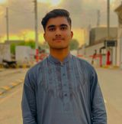

**My best childhood memory**

I remember my childhood days where me and my friends have another different world where we waited for each other and play together . I live in manora. Every Sunday we visit seaside and enjoy lot of happiness. We grew up and our responsibilities increased but I cannot forget my those childhood days.





**My inspiration**

My inspiration is Allama Iqbal. I like him and his poetry. His way for through he wake up the nation is commendable. When our nation was sleeping he always motivated our nation. He is leader of our nation. He was one man army

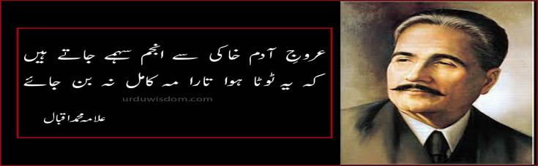



**My favorite sport**

Cricket is my favourite game. I am opener batsman and alhamdullilah as opener I am also captain of my team. Opening is not easy but I have ability to serve my team in critical situation.





**Where do I see myself in five years?**

I see myself In five year as a successful software engineer. I see myself in future serving Pakistan and inshallah I will do my best for my country to become developing country.



**My social networking sites/link.**

FACEBOOK: **<https://web.facebook.com/sajjadahsan416/>**